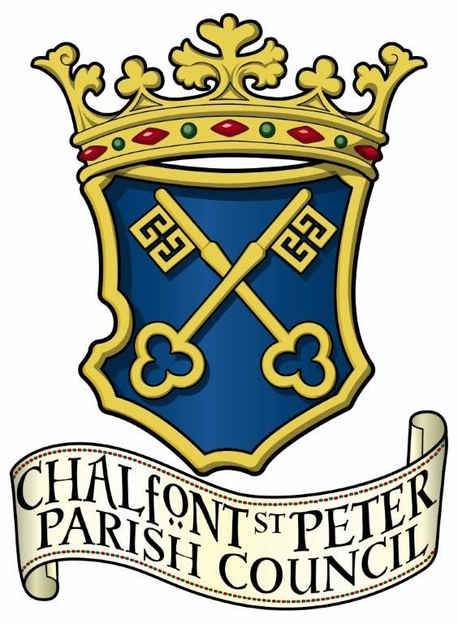
Chalfont St Peter Parish Council
Comms & PR COMMITTEE

Terms of Reference
Reviewed: August 2023

Committee Constitution
Refer to Standing Orders

Aims
To develop and maintain better communications both within the Council and between the Council and the wider community.

Responsibilities

- To monitor and review the lines of communication by the Council with other local
government organisations, local media, members of the public and other voluntary groups e.g. Village Action Group, Neighbourhood Action Group, Chamber of Commerce etc.

- To monitor and review internal communication within the Council, its employees
and committees and in doing so provide the best possible delivery of the Council’s objectives and obligations.

- To communicate the Council’s objectives both internally and externally, as
appropriate.

- To optimise the Council’s presence in the community as a relevant source of
information using social media, including the website, Facebook, Twitter and digital
communication direct to residents

- To monitor the installation and management of the Council’s public notice boards.

- To utilise all opportunities for communication within the village such as the library,
schools and local shops and the Council’s own database to keep the public informed of important Village information.

These terms will be reviewed annually.

