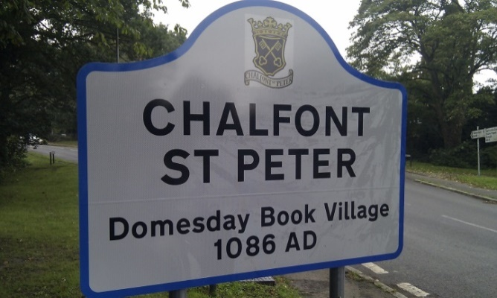Chalfont St Peter Village Voice – February 2025

Founder Editor: Elaine Quigley   [elainequigley@sky.com](mailto:elainequigley@sky.com)

The following items have been kindly submitted by Anita Wallace of the Chalfont St Peter Community Library:



**UPCOMING EVENTS**

**Please put the following dates in your diary**

**5th, 12th, 26th February** 10.30 am Bounce and Rhyme

**5th, 12th 19th, 26th February** 2pm-5pm – Tea/Coffee and Biscuits. Suggested donation, £1

**10th February**  **Mid-month Classic Film: 2.30pm, ‘Groundhog Day’**

**24th February** Movie Monday – films tba

**5th, 12th, 19th, 26th March** 10.30 am Bounce and Rhyme

2.30pm – Tea/Coffee and biscuits. Suggested donation, £1

**17th March**  7pm - Chalfont St Peter Community Library AGM

**26th April** (tbc) 2pm - Crime Quarterly – Meet the Author

**Monday, 10th February - Mid-month Classic Film**

✨🎬   
  
Join us at Chalfont St Peter Community Library to watch the movie **Groundhog Day** as it will be shown on Monday, 10th February at 2.30pm in the Library.  
  
📍 **Where: Chalfont St Peter Community Library   
🗓 Monday, 10th February  
🕝 2:30 PM**   
  
🎟 **Tickets are free and available from the library**! Walk-ins welcome if seating allows.   
💖 Donations on the day are very much appreciated — every penny helps keep our wonderful library running for the community!

Please see the poster on the following page



**Fancy a Brew and a Biscuit?**

Fancy a warm drink and a treat in cosy and comfortable surroundings? Stop by Chalfont St Peter Community Library on **Wednesdays, between 2pm and 5pm**, for a relaxing cup of tea or coffee ☕, plus biscuits! 🍪 All for just a suggested donation of £1. Come unwind with us!   
  
📍 Chalfont St Peter Library   
🗓️ Wednesday   
⏰ 2pm - 5pm   
  
See you there! 👋

Please see the poster on the following page



-o0o-

The following article has been kindly submitted by Matthew Barber

(Police & Crime Bulletin December 2024 by Matthew Barber, Police & Crime Commissioner for Thames Valley):

[Police & Crime Bulletin Jan ‘25 -Crime prevention, shop theft & child abuse](https://matthewbarber.co.uk/campaigns/view-email/XX6VPkkeXXUUJvbQF13BVrkmxWcFdf0lDE_XrOvXBcydh_e3QLUtxUmuVTu1lfwR09A8DR6ABoCshRbEmG4yHvz0ToNnQIqQpO-NPzNxmNpGKz0qj0mjbcNnbtCHv9usBCs2d_N7G9c6nZq50g6cYgX5pbJch6Vw87csQw==?ss_source=sscampaigns&ss_campaign_id=679d153423692c7de15bca5e&ss_email_id=679d1743b7c7fb5d344896f5&ss_campaign_name=Police+%26+Crime+Bulletin+Jan+%E2%80%9825+-Crime+prevention%2C+shop+theft+%26+child+abuse&ss_campaign_sent_date=2025-01-31T18%3A32%3A54Z)

-o0o-

The following article has been kindly submitted by Ann Middleton:

There is a **Come and Sing** event taking place on **Saturday 22nd February** at All Saints Church in Oval Way.

Whether you are a singer who would like to take part or want to attend the public performance

**at 3.30pm** that day then should be a very enjoyable experience!

Please circulate it to friends and family as well as to anyone that you think would find it of interest.



The following article has been kindly submitted by David Powell:

**NOTE: If you are not a Chalfonts u3a member then you can visit** [**www.chalfontsu3a.org.uk**](http://www.chalfontsu3a.org.uk) **and sign up there**



-o0o-

The following information has been kindly submitted by Karen Dickson:



-o0o-

The following article has been kindly submitted by Stewart Walker:

[National Garden Scheme Opening - Cornfield Cottage](https://findagarden.ngs.org.uk/garden/45644/cornfield-cottage)

Not only is it a lovely day out but raises money for charity as well!

-o0o-

The following article has been kindly submitted by Alan Parrott:

 

|  |  |  |  |
| --- | --- | --- | --- |
| |  | | --- | | [Message Type Icon](https://cdn.neighbourhoodalert.co.uk/messageTypeIcons/Mt6P3.jpg) | | |  | | --- | | Man jailed for stealing more than £223,000 from small business | |

|  |  |  |  |  |  |  |  |
| --- | --- | --- | --- | --- | --- | --- | --- |
| |  |  |  |  |  |  |  | | --- | --- | --- | --- | --- | --- | --- | | |  | | --- | |  |  |  |  |  | | --- | --- | --- | | |  |  | | --- | --- | | https://ecp.yusercontent.com/mail?url=https%3A%2F%2Fcdn.neighbourhoodalert.co.uk%2F85%2F8596%2F609a252a-4be3-4ab2-a527-f5afb6ae5298.jpg&t=1738742431&ymreqid=a644e47f-fed7-fd88-1c18-32000201e600&sig=yIYoElA.XS.IlSmsIcTdkQ--~D |  | | | |  | | --- | |  | | |
|  |

Following our investigation, a man has been jailed for five years and four months after stealing more than £223,000 from a small business.

Please refer to the following link for more information:

[Man arrested for stealing large amount of money from small business](https://www.thamesvalleyalert.co.uk/Alerts/A/239811/Man-jailed-for-stealing-more-than-223000-from-small-business)

-o0o-

The following article has been kindly submitted by Alan Parrott:

|  |  |  |  |  |
| --- | --- | --- | --- | --- |
| |  |  |  |  | | --- | --- | --- | --- | | |  | | --- | | [Thames Valley Alert Logo](https://www.thamesvalleyalert.co.uk/) | | |  | | --- | | The Police | | |
| |  |  |  |  | | --- | --- | --- | --- | | |  | | --- | | [Message Type Icon](https://cdn.neighbourhoodalert.co.uk/messageTypeIcons/Mt6P3.jpg) | | |  | | --- | | Social Media Summary | | |

Please refer to the following link for further information -> [Social Media Summary - 03/02/25](https://www.thamesvalleyalert.co.uk/Alerts/A/239831/Social-Media-Summary)